Report on the project 1
Calssifying LEGO
Nikita Gagaev
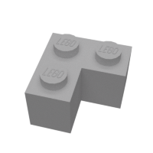
To make my project more independent of other projects I found out a Lego data set, so I will be using it.
The aim of the project:
The task is to design and prototype an image processing system to detect the different shapes and classes of lego bricks and to classify them properly.
We have a set of images of Lego bricks, which should be sorted in a proper way. The goal is to identify the demension of the birck to sort it in proper way and put it in right LEGO box.
Project content:
- '\lego-brick-images': The directory contains the training material, divided in 10 classes and contain over 3900 images, Classes are 2x2 brick, 2x1 brick, 1x1 brick, 2x2x1 birck, 1x2 plate brick, 2x2 plate brick, 1x1 plate brick, 1x2 roof brick, 1x2 flat brick, 1x2 brick with one knob.
- 'Load_dataset.py': This keras based deep-learning algorithm which trains the network to classify the bircks and our main program.
- ‘model.h5’: The file contains weights that have been saved after the training. File is produced by the algorithm and can be used again to use old weights and update them.
- ‘File.json’: The comparison of actual data classification and the predictions made by algorithm.
Page 1
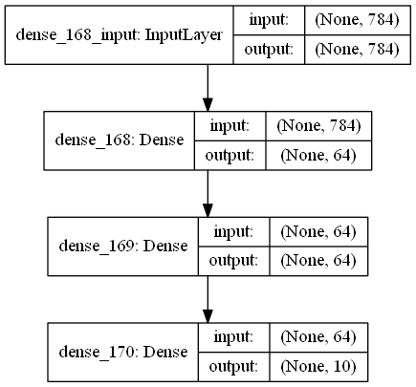
- ‘model.png’: The graphical representation of network layers structure:

For the input we have 1-dimentional array of 784 elements and as the output we get a 1-dimentional array of 10 elements (the same as the number of classes).
Neural network itself:
First, we load the training and testing data from ‘\lego-brick-images\test’ and ‘\lego-brick-images\train’ directories. The number of training data is 3984 and the number of test data is 618.
Then using the iterators we create the training and testing numpy image arrays and label arrays.
We reshape the array in order to get 1-dimentional of 784 size array for training the data. Reshaping built upon the fact that there 28x28 pixels.
After that we set our training model by having 3 layers: 2x Relu and 1 sigmoid. We can see it in the ‘model.png’ picture.
Then we train the model using training data and labels, and evaluated the obtained model (with the obtained weights) using the testing data and labels.
We print the actual classification of testing data and the predicted classification of testing data. Usually the accuracy is close to 0.9.
Page 2
After that we print the accuracy and the loss plots.
When we compile our algorithm on 500 epochs we can see something like this:
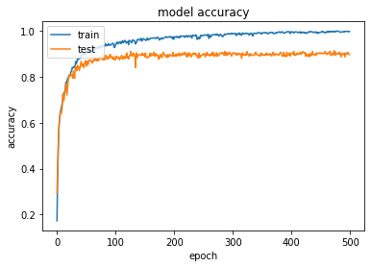
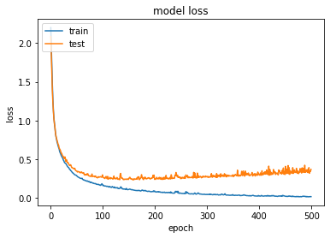

And there is a reason for this:
Page 3

This is 2x2 brick:

And this is 1x1 brick:
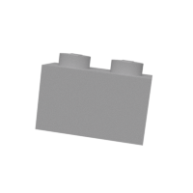
For obvious reasons our neural network is confused as we are! So sometimes the accuracy never can reach 1.
On the table below we can see the comparison of prediction model to real labels.
Page 4
Conclusion:
To classify and sort lego bricks neural network that classifies based on the pictures is extreamly good option. The more epoch we have the more accuracy we obtain, but we should avoid some images that are look like one another. But this can be handled with large masives of data, the lack of data is important we can not solve it by just incremention iterations. Even after 1500 epochs the accuracy is around 1, but not 1 for every epoch! So we don't have anough data to train it more, so sometimes mistakes can occure. One way how to increase accuracy is to add more layers! On initial project I had 3 layers, but when i added one more, the accuracy grow faster and the number of mistakes reduced.

Page 5

